**Women’s T20 World Cup 2023**

Its cricket, cricket and more cricket for cricket-crazy Indian fans. It’s going to be a cricket bonanza, with so many cricket matches lined-up till the month of May. Women’s U-19 World Cup has just ended and now we have Women’s T20 World Cup. Indian team’s captain Harmanpreet Kaur and her team will be eager to show unleash their power.

**Women’s T20 history.**

The first Women’s Twenty20 matches took place on 29 May 2004. It was a warm-up match for the first ever Women’s Twenty20 International (first T20 for either gender). **Thetidkes** has good quality [cricket equipment](https://thetidkes.com/shop/) online in India at the best price. The first Women’s T20 International match was held in 5 August 2004 between England and New Zealand. The first T20 Women’s World Cup was held in 2009 in England and the host was the winner. The first Women’s U-19 T20 World Cup was held recently in South Africa from 14 - 29 January 2023.

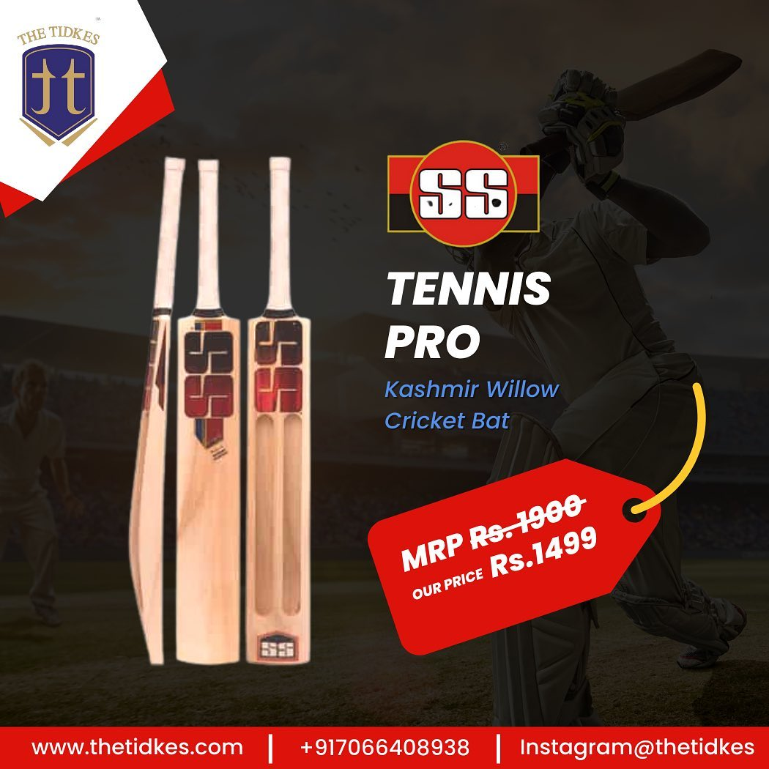

The last T20 International World Cup was held in Australia in 2020 and the next world cup is scheduled to be held in Bangladesh in 2024. It is a biennial International Championship. Australia has been the most successful team with five titles to its credit. India has so far not won a single title but was runner-up in last match. It was watched by most spectators ever for a women’s cricket event. Team India’s captain Harmanpreet Kaur and her team will be very well geared up for this World Cup, as they are aware of their potential. But the most awaited match will undoubtedly be the India-Pakistan match. And the people of these two countries will be glued to cricket live score wherever they maybe. India was also the winner of Women’s Asia Cup. It was their seventh tile. The Indian women cricketers have a lot to gain in terms of popularity and viewership with the inaugural edition of women’s premier league scheduled for next month in India.

**Women’s T20 World Cup 2023**

ICC Women’s T20 World Cup 2023 is currently being held in South Africa from 10th to 26 Feb 2023. It is the eighth edition. There are 10 participants that will be playing in all 23 matches. Australia is the defending champion. The Indian team had lost to Australia in the final. South Africa had earlier hosted the inaugural edition of Women’s U - 19 T20 World Cup 2023 in Jan 14th to 29th. Team India had won the first edition of this tournament after beating England in the finals and they will be looking forward to enhance their performance in this tournament and keep the viewers glued to the TV sets for cricket live score.

The cricket teams are divided into two groups. Group A and Group B.

The two groups are -

|  |  |
| --- | --- |
| **Group A** | **Group B** |
| Australia  Bangladesh  New Zealand  South Africa  Sri Lanka | England  India  Ireland  Pakistan  West Indies |

Participants: 10

Matches: 23

Tournament format: Round-robin and knockout

Cricket format: Women’s Twenty20 International

Host: South Africa

Administrator: International Cricket Council

**Semi finals**

The semi-finals will be held on 23February 2023 with

Winner of Group 1 **Vs** Runner-up Group 2

On 24 February 2023 with

Winner of Group 2 **Vs** Runner-up Group 1

**Finals**

The finals will be held on 26 February 2023

Winner of Semi Final Group 1 **Vs** Winner of Semi Final Group 2

The cricket fans in India will be expecting their team to lift the cup in this tournament as they have tasted victory in the Women’s U-19 World Cup only recently. A win here would raise the hope of a billion viewers in India and BCCI will be only hoping to cash-in for the coming Women’s premier league.

Thank you for reading this article. We at [thetidkes](https://thetidkes.com/) are confident that our women cricketers will put in their best and make our country proud. We also hope that many of our young women will now take up cricket as a sport and career.

All guys and gals do visit our ecommerce platform [thetidkes](https://thetidkes.com/). This is one of [best online sport shop in india](https://thetidkes.com/) for the best cricket equipment and all sports related equipment and accessories. Best quality of [SS Kashmir Willow Cricket Bat](https://thetidkes.com/product/kashmir-willow-cricket-bat/) , Kahmir willow cricket bat online at best price. They have all types of other sports like badminton, football, basketball, volleyball and table tennis, etc. Do visit our retail store, **TT SPORTS, at Akola, Maharashtra** to find a wide range of sports products and accessories. We are authorized distributors of COSCO, Yonex, Nivia, Spartan, SS, Tennex, Konex and many more Indian and global brands.

You can contact us through social media.

Instagram: [@thetidkes](https://href.li/?https://www.instagram.com/thetidkes)

Facebook: [Tidke Exporters and Traders Private Limited](https://t.umblr.com/redirect?z=https%3A%2F%2Fwww.facebook.com%2Fthetidkes&t=ODRkNDQwZDNiNjJlYzVmYzA5NzFjYjQwNGE2NjE0NDJlN2RmMjRhNixhMTU3Yzg0YWU4OGIzNzZmZjVjMDFmYTA5NGRlMzIyMzU2MmQ2ZTQ1&ts=1671786578" \t "_blank)

